|  |
| --- |
| Circuit Theory |
| MATLAB Assignment |
| SAMBHAV R JAIN 107108103 |

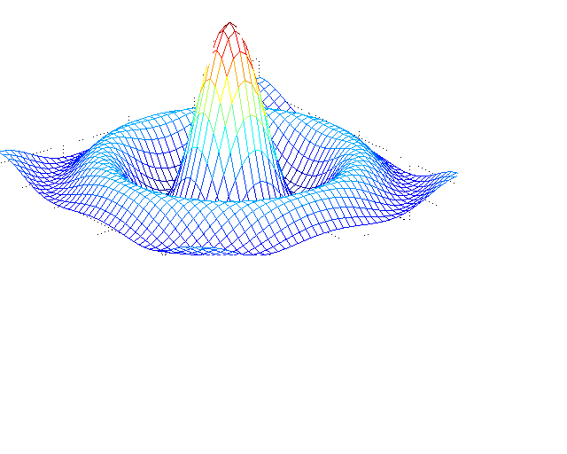

**Question 1**

**CIRCUIT DIAGRAM:**

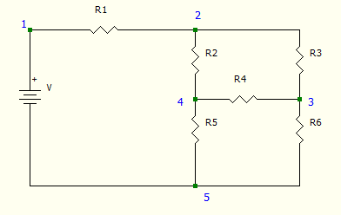

**PROGRAM CODE:**

clear all;

close all;

clc;

%The circuit diagram is as shown.

V=input('Enter the value of voltage source in the figure:\n');

R=zeros(1,6);

disp('Enter the six resistors R1,R2,R3,R4,R5,R6:');

for i=1:6

R(i)=input('');

end

disp('Applying Loop analysis to the given circuit:');

r=[R(1)+R(2)+R(5) -R(2) -R(5);R(2) -R(2)-R(3)-R(4) R(4);R(5) R(4) -R(4)-R(5)-R(6)]

v=[V;0;0]

I=inv(r)*v;

disp('The loop currents are:');

disp('I1=');

disp(I(1));

disp('I2=');

disp(I(2));

disp('I3=');

disp(I(3));

disp('Hence the current through the 2 ohm resistor is:');

disp(I(3)-I(2));

**OUTPUT:**

Enter the value of voltage source in the figure:

10

Enter the six resistors R1,R2,R3,R4,R5,R6:

6

4

6

2

8

15

Applying Loop analysis to the given circuit:

r =

18 -4 -8

4 -12 2

8 2 -25

v =

10

0

0

The loop currents are:

I1=

0.7341

I2=

0.2877

I3=

0.2579

Hence the current through the 2 ohm resistor is:

-0.0298

**Question 2**

**CIRCUIT DIAGRAM:**

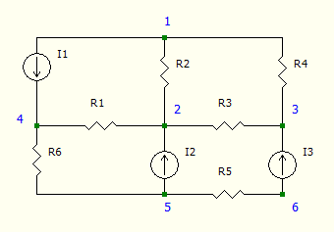

**PROGRAM CODE:**

clear all;

close all;

clc;

%The circuit diagram is as shown.

I=zeros(1,3);

disp('Enter the three current sources I1,I2,I3:');

for i=1:3

I(i)=input('');

end

R=zeros(1,6);

disp('Enter the six resistors R1,R2,R3,R4,R5,R6:');

for i=1:6

R(i)=input('');

end

disp('Let the node 5 be grounded.');

disp('Applying KCL to the given circuit:');

r=[0 -1/R(1) 0 1/R(1)+1/R(6);-1/R(2) 1/R(1)+1/R(2)+1/R(3) -1/R(3) -1/R(1);-1/R(4) -1/R(3) 1/R(3)+1/R(4) 0;-1/R(2)-1/R(4) 1/R(2) 1/R(4) 0];

i=[I(1);I(2);I(3);I(1)];

%This variable v stores from V1 to V4 only.

v=inv(r)*i;

v(5)=0;

disp('The nodal voltages are:');

disp('V1=');

disp(v(1));

disp('V2=');

disp(v(2));

disp('V3=');

disp(v(3));

disp('V4=');

disp(v(4));

%Since the node 5 was grounded.

disp('V5=');

disp(v(5));

disp('V6=');

disp(-I(3)*R(5));

**OUTPUT:**

The circuit diagram is as shown:

Enter the three current sources I1,I2,I3:

3

4

6

Enter the six resistors R1,R2,R3,R4,R5,R6:

2

5

3

6

8

4

Let the node 5 be grounded.

Applying KCL to the given circuit:

The nodal voltages are:

V1=

50.7857

V2=

54

V3=

64.9286

V4=

40

V5=

0

V6=

-48

**Question 3**

**CIRCUIT DIAGRAM:**

1. **To calculate Thevenin Voltage:**
2. **To calculate Thevenin Resistance:**

**PROGRAM CODE:**

clear all;

close all;

clc;

%The circuit diagram is as shown

%To calculate Thevenin Voltage

disp('Enter the value of voltage source S:');

S=input('');

disp('Enter the value of current source I:');

I=input('');

R=zeros(1,3);

disp('Enter the resistances R1,R2,R3:');

for i=1:3

R(i)=input('');

end

%Let the 5th node be grounded

V5=0;

V2=V5+S;

V3=V2-6*I;

V4=V5-I*R(3);

V1=(V3*(3+1/R(2))+V2/R(1))/(3+1/R(1)+1/R(2));

Vt=V4-V1;

disp('The voltages at the nodes 1,2,3,4,5 are:');

disp(V1);

disp(V2);

disp(V3);

disp(V4);

disp(V5);

disp('The Thevenin voltage is:');

disp(Vt);

%To calculate Thevenin Resistance

%The loop currents are I,i2,i3,i4

r=[-R(1)-R(2) R(1) -6;12 1 1;R(1) -R(1) 2];

v=[6*I;0;-2*I-S];

i=inv(r)*v;

disp('The short circuit current is:');

disp(i(3));

Rt=Vt/i(3);

disp('Hence the Thevenin resistance is:');

disp(abs(Rt));

disp('This Rth remains constant for different values of load resistances.');

%To calculate the power dissipated by 4 ohms

Il(1)=Vt/(abs(Rt)+4);

P=(Il(1)^2*4);

disp('The power dissipated by 4 ohm load (in watts) is:');

disp(P);

%Equivalent Norton circuit

disp('The equivalent Norton circuit has:');

disp('In=');

In=Vt/abs(Rt);

disp(In);

disp('Rn=');

disp(abs(Rt));

%To plot the graph1

Rl=4:4:40;

for i=1:10

Il(i)=Vt/(abs(Rt)+Rl(i));

end

plot(Il,Vt);

xlabel('Load current----->');

ylabel('Thevenin Voltage----->');

title('Thevenin Voltage v\s Load current');

%To plot the graph2

t=0:.001:10;

plot(t,Vt);

xlabel('Time----->');

ylabel('Thevenin Voltage----->');

title('Thevenin Voltage v\s Time');

%To plot the graph3

plot(Il);

xlabel('Time----->');

ylabel('Load current----->');

title('Load current v\s Time');

**OUTPUT:**

Enter the value of voltage source S:

10

Enter the value of current source I:

8

Enter the resistances R1,R2,R3:

2

4

2

The voltages at the nodes 1,2,3,4,5 are:

-31.6000

10

-38

-16

0

The Thevenin voltage is:

15.6000

The short circuit current is:

-5.3182

Hence the Thevenin resistance is:

2.9333

This Rth remains constant for different values of load resistances.

The power dissipated by 4 ohm load (in watts) is:

20.2500

The equivalent Norton circuit has:

In=

5.3182

Rn=

2.9333

**GRAPHS:**

1. **VTH v\s IL**

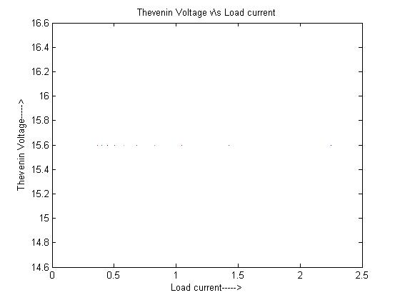

1. **IL v\s t**

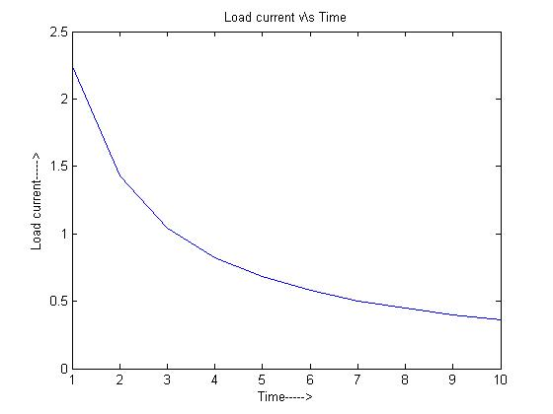

1. **VTH v\s t**

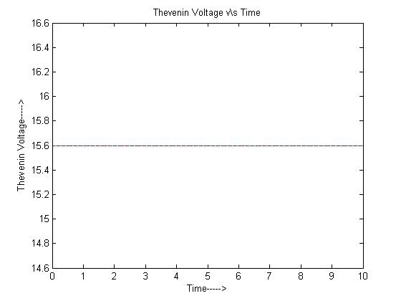

**Question 4**

**CIRCUIT DIAGRAM:**

1. **To calculate Thevenin Voltage:**
2. **To calculate Thevenin Resistance:**

**PROGRAM CODE:**

clear all;

close all;

clc;

%The circuit diagram is as shown.

disp('Enter the values of sources S1 and S2:');

S1=input('');

S2=input('');

R=zeros(1,6);

disp('Enter the resistors R1,R2,R3,R4,R5');

for i=1:5

R(i)=input('');

end

%Let the 1st node be grounded

%To calculate Thevenin Voltage

V1=0;

V4=S1;

V5=S2;

x=[-1/R(3) 1/R(1)+1/R(2)+1/R(3);1/R(3)+1/R(4) -1/R(3)];

y=[V4/R(1);V5/R(4)];

v=inv(x)*y;

Vt=v(1);

disp('Thus the Vth is:');

disp(Vt);

%To calculate Thevenin Resistance

a=R(1)*R(2)/(R(1)+R(2));

b=a+R(3);

c=b*R(4)/(b+R(4));

d=c+R(5);

Rt=d;

disp('The Rth is:');

disp(Rt);

%Power dissipation by load

i=0;

for r=0:2:12

i(1,(r/2)+1)=Vt/(Rt+r);

end

r=[0 2 4 6 8 10 12];

disp('Power dissipated varies as:');

P=(i.^2).*r

plot(r,P);

xlabel('Load Resistance');

ylabel('Power dissipated');

disp('Maximum power dissipated is: 9.3750 Watts');

disp('Maximum power is dissipated at 6 ohms load');

**OUTPUT:**

Enter the values of sources S1 and S2:

12

36

Enter the resistors R1,R2,R3,R4,R5

3

6

2

12

3

Thus the Vth is:

15

The Rth is:

6

Power dissipated varies as:

P =

0 7.0313 9.0000 9.3750 9.1837 8.7891 8.3333

Maximum power dissipated is: 9.3750 Watts

Maximum power is dissipated at 6 ohms load

**GRAPH:**

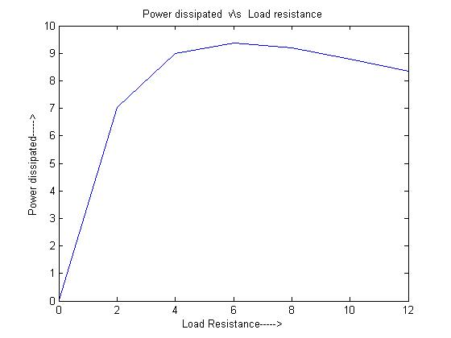

**Question 5**

**CIRCUIT DIAGRAM:**

Wye network Delta network

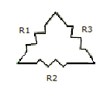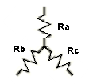

**PROGRAM CODE:**

clear all;

close all;

clc;

n=input('Choose: \n1. delta-wye \n2. wye-delta \n');

if n==1

d=input('Enter the value of R1, R2, R3 of Delta connected circuit :\n');

s=sum(d);

w(1,1)=d(1,1)*d(1,3)/s;

w(1,2)=d(1,1)*d(1,2)/s;

w(1,3)=d(1,2)*d(1,3)/s;

disp('The Ra, Rb, Rc of Wye connected circuit are :');

disp(w);

elseif n==2

w=input('Enter the value of Ra, Rb, Rc of Wye connected circuit :\n');

s=w(1,1)*w(1,2)+w(1,2)*w(1,3)+w(1,1)*w(1,3);

d(1,1)=s/w(1,3);

d(1,2)=s/w(1,1);

d(1,3)=s/w(1,2);

disp('The R1, R2, R3 of Delta connected circuit are :');

disp(d);

end

**OUTPUT:**

Choose:

1. delta-wye

2. wye-delta

1

Enter the value of R1, R2, R3 of Delta connected circuit :

[1 2 3]

The Ra, Rb, Rc of Wye connected circuit are :

0.5000 0.3333 1.0000

Choose:

1. delta-wye

2. wye-delta

2

Enter the value of Ra, Rb, Rc of Wye connected circuit :

[1 2 3]

The R1, R2, R3 of Delta connected circuit are :

3.6667 11.0000 5.5000

**GRAPH: (Program 4)**

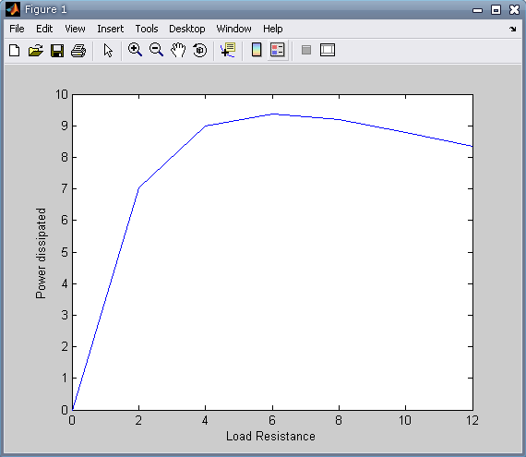

**GRAPH: (Program 3)**

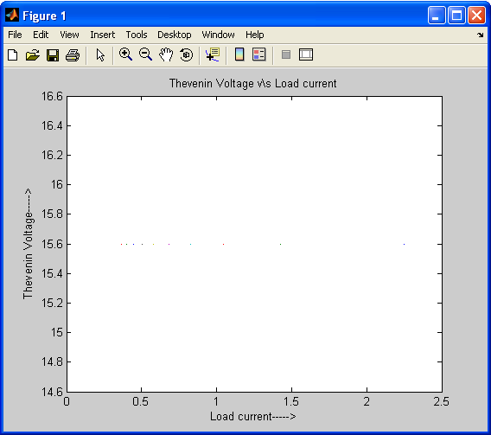

**GRAPH: (Program 3)**

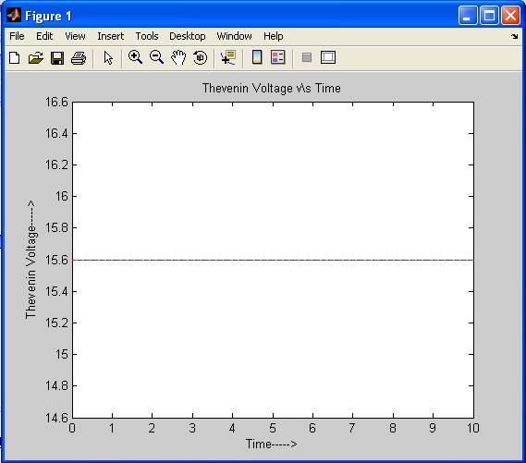

**GRAPH: (Program 3)**

